1. CREATE DATABASE
MongoDB Query:
use Students
Explanation: Creates or switches to the Student database.
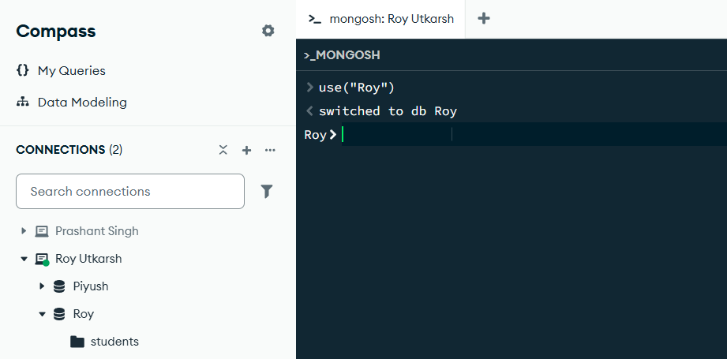

2. CREATE COLLECTION
MongoDB Query:
db. create Collection("students")
Explanation: Creates a collection named students.

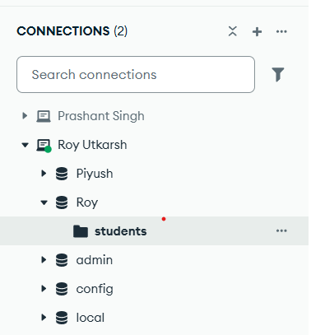

3. INSERT 50 STUDENTS
MongoDB Query:
db. students. Insert Many([
{ rollNo: 1, name: "Aarav Patel", age: 19, marks: 78, city: "Ahmedabad" },
{ rollNo: 2, name: "Diya Shah", age: 20, marks: 85, city: "Surat" },
{ rollNo: 3, name: "Vivaan Mehta", age: 19, marks: 72, city: "Vadodara" },
{ rollNo: 4, name: "Anaya Desai", age: 18, marks: 91, city: "Rajkot" },
{ rollNo: 5, name: "Arjun Patel", age: 20, marks: 68, city: "Gandhinagar" },
{ rollNo: 6, name: "Kiara Shah", age: 19, marks: 88, city: "Bhavnagar" },
{ rollNo: 7, name: "Reyansh Joshi", age: 18, marks: 76, city: "Jamnagar" },
{ rollNo: 8, name: "Myra Mehta", age: 20, marks: 94, city: "Ahmedabad" },
{ rollNo: 9, name: "Aditya Desai", age: 19, marks: 81, city: "Surat" },
{ rollNo: 10, name: "Riya Patel", age: 18, marks: 73, city: "Vadodara" },

{ rollNo: 11, name: "Krish Shah", age: 20, marks: 89, city: "Rajkot" },
{ rollNo: 12, name: "Aadhya Joshi", age: 19, marks: 95, city: "Gandhinagar" },
{ rollNo: 13, name: "Dhruv Patel", age: 18, marks: 67, city: "Bhavnagar" },
{ rollNo: 14, name: "Ishita Desai", age: 20, marks: 82, city: "Jamnagar" },
{ rollNo: 15, name: "Yash Mehta", age: 19, marks: 74, city: "Ahmedabad" },
{ rollNo: 16, name: "Avni Shah", age: 18, marks: 90, city: "Surat" },
{ rollNo: 17, name: "Harsh Patel", age: 20, marks: 79, city: "Vadodara" },
{ rollNo: 18, name: "Navya Desai", age: 19, marks: 87, city: "Rajkot" },
{ rollNo: 19, name: "Rudra Joshi", age: 18, marks: 71, city: "Gandhinagar" },
{ rollNo: 20, name: "Meera Patel", age: 20, marks: 93, city: "Bhavnagar" },

{ rollNo: 21, name: "Kunal Shah", age: 19, marks: 65, city: "Jamnagar" },
{ rollNo: 22, name: "Isha Mehta", age: 18, marks: 84, city: "Ahmedabad" },
{ rollNo: 23, name: "Manav Patel", age: 20, marks: 77, city: "Surat" },
{ rollNo: 24, name: "Saanvi Desai", age: 19, marks: 92, city: "Vadodara" },
{ rollNo: 25, name: "Dev Joshi", age: 18, marks: 69, city: "Rajkot" },
{ rollNo: 26, name: "Kavya Shah", age: 20, marks: 86, city: "Gandhinagar" },
{ rollNo: 27, name: "Rohan Patel", age: 19, marks: 75, city: "Bhavnagar" },
{ rollNo: 28, name: "Tanya Mehta", age: 18, marks: 89, city: "Jamnagar" },
{ rollNo: 29, name: "Nirav Desai", age: 20, marks: 80, city: "Ahmedabad" },
{ rollNo: 30, name: "Pooja Patel", age: 19, marks: 96, city: "Surat" },

{ rollNo: 31, name: "Siddharth Shah", age: 18, marks: 70, city: "Vadodara" },
{ rollNo: 32, name: "Nisha Joshi", age: 20, marks: 83, city: "Rajkot" },
{ rollNo: 33, name: "Mihir Patel", age: 19, marks: 88, city: "Gandhinagar" },
{ rollNo: 34, name: "Jhanvi Desai", age: 18, marks: 78, city: "Bhavnagar" },
{ rollNo: 35, name: "Parth Mehta", age: 20, marks: 91, city: "Jamnagar" },
{ rollNo: 36, name: "Khushi Shah", age: 19, marks: 74, city: "Ahmedabad" },
{ rollNo: 37, name: "Darsh Patel", age: 18, marks: 85, city: "Surat" },
{ rollNo: 38, name: "Riddhi Joshi", age: 20, marks: 97, city: "Vadodara" },
{ rollNo: 39, name: "Meet Desai", age: 19, marks: 66, city: "Rajkot" },
{ rollNo: 40, name: "Mansi Patel", age: 18, marks: 81, city: "Gandhinagar" },

{ rollNo: 41, name: "Jay Shah", age: 20, marks: 79, city: "Bhavnagar" },
{ rollNo: 42, name: "Hetal Mehta", age: 19, marks: 90, city: "Jamnagar" },
{ rollNo: 43, name: "Akash Patel", age: 18, marks: 73, city: "Ahmedabad" },
{ rollNo: 44, name: "Pallavi Desai", age: 20, marks: 87, city: "Surat" },
{ rollNo: 45, name: "Raj Joshi", age: 19, marks: 82, city: "Vadodara" },
{ rollNo: 46, name: "Simran Shah", age: 18, marks: 94, city: "Rajkot" },
{ rollNo: 47, name: "Sahil Patel", age: 20, marks: 68, city: "Gandhinagar" },
{ rollNo: 48, name: "Neha Mehta", age: 19, marks: 76, city: "Bhavnagar" },
{ rollNo: 49, name: "Vatsal Desai", age: 18, marks: 89, city: "Jamnagar" },
{ rollNo: 50, name: "Palak Joshi", age: 20, marks: 93, city: "Ahmedabad" }
])
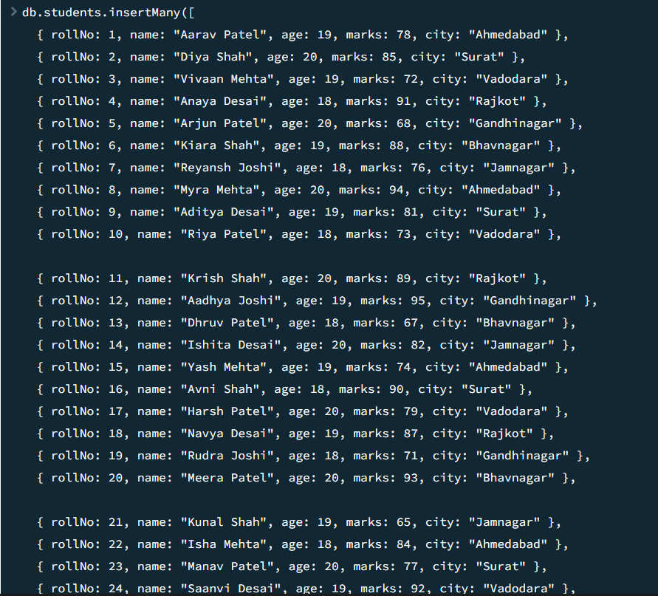
Explanation: Inserts multiple student documents into the collection.

4. DISPLAY ALL STUDENTS
MongoDB Query:
db. students. Find ()
Explanation: Retrieves documents from the students collection.
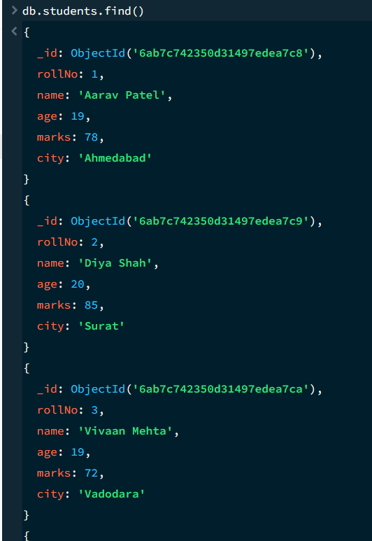

5. EQUAL TO — $eq
MongoDB Query:
db. students. Find ({marks: {$eq: 88}})
Explanation: Finds students whose marks are exactly 88.

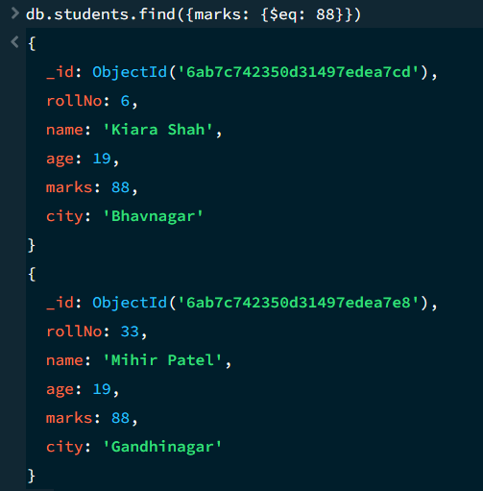
6. GREATER THAN — $gt
MongoDB Query:
db.students.find({marks: {$gt: 85}})
Explanation: Finds students whose marks are greater than 85.
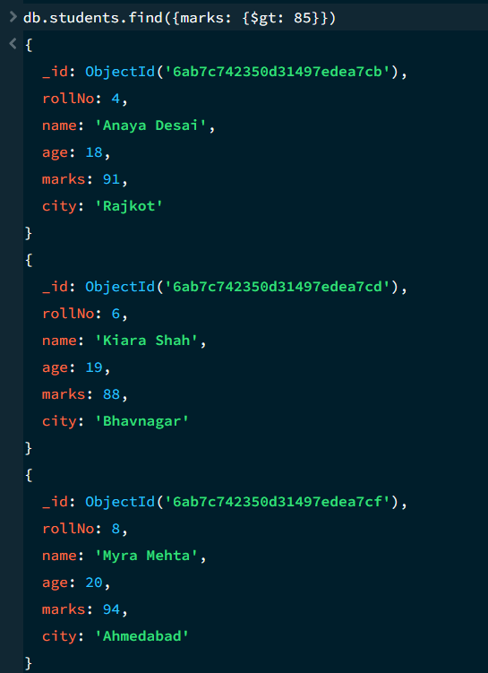

7. LESS THAN — $lt
MongoDB Query:
db. students. find ({marks: {$lt: 70}})
Explanation: Finds students whose marks are less than 70.

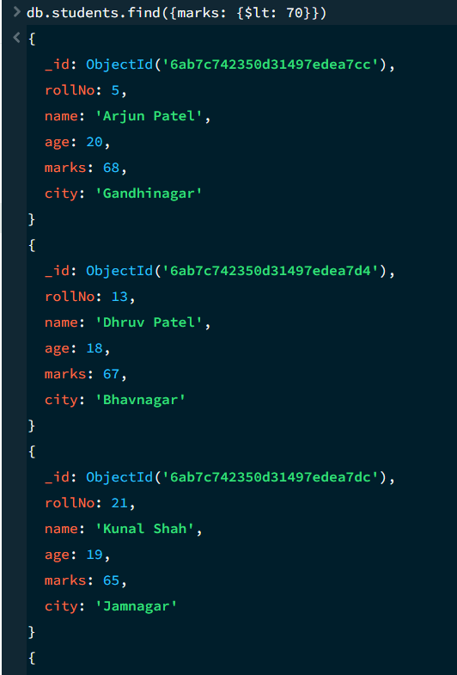
8. GREATER THAN OR EQUAL TO — $gte
MongoDB Query:
db. students. find({marks: {$gte: 90}})
Explanation: Finds students whose marks are 90 or above.
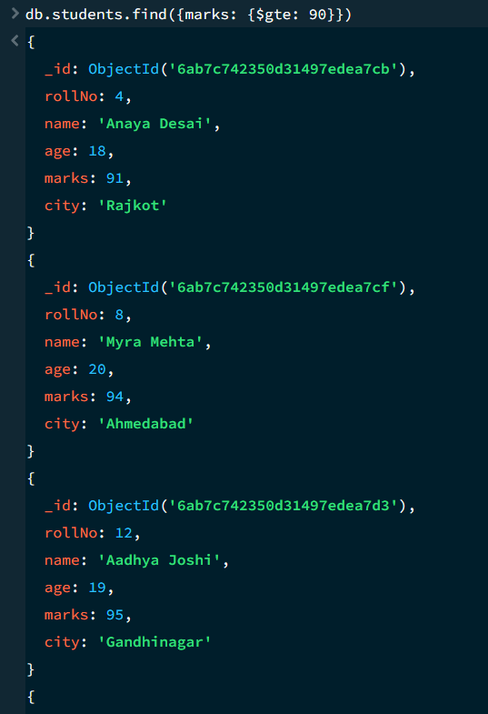

9. LESS THAN OR EQUAL TO — $lte
MongoDB Query:
db. students. find({marks: {$lte: 70}})
Explanation: Finds students whose marks are 70 or below.
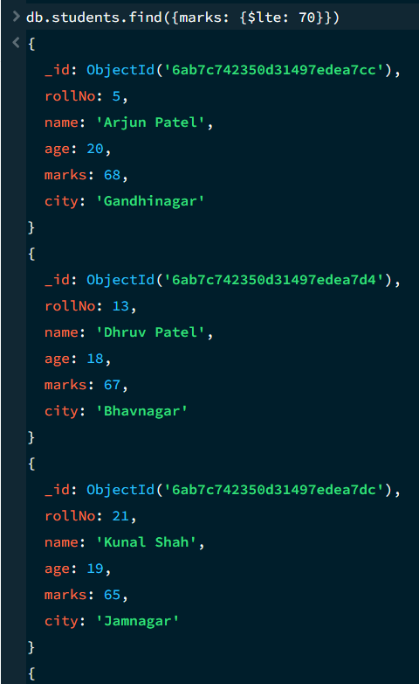

10. UPDATE OPERATION
MongoDB Query:
db.students.updateOne(
{roll:5},
{$set:{marks:95}}
)
Explanation: Updates the marks to 95 of the student with roll number 5.

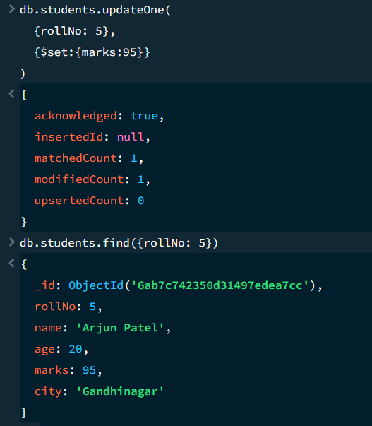

11. DELETE ONE OPERATION
MongoDB Query:
db.students.deleteOne({roll:10})
Explanation: Deletes one document matching roll number 10.
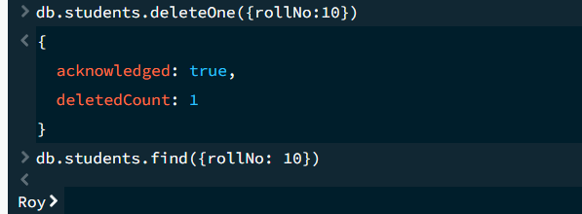

12. DELETE MANY OPERATION
MongoDB Query:
db.students.deleteMany({
marks: {$lt:60}
})
Explanation: Deletes all students having marks below 60.
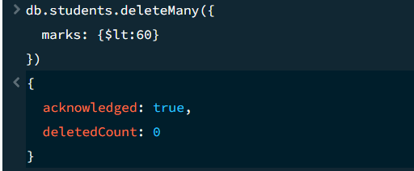

13. AND OPERATION — $and
MongoDB Query:
db. students. find({
$and:[
{marks:{$gt:80}},
{age:19}
]
})
Explanation: Finds students satisfying both conditions.
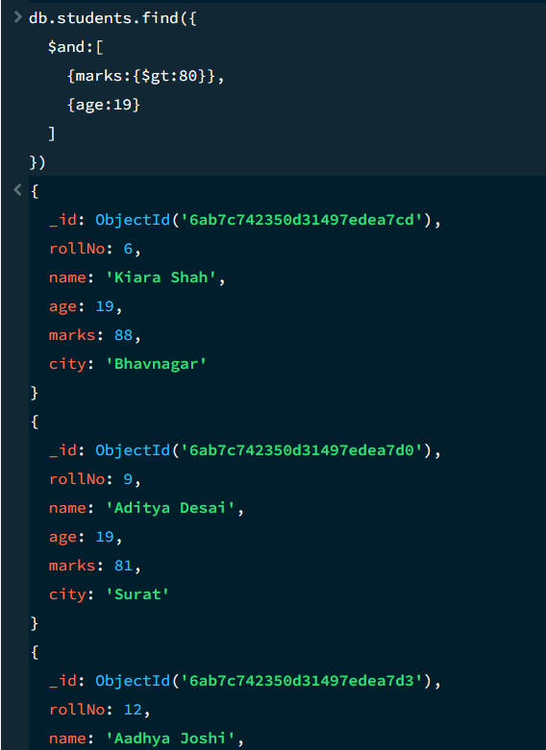

14. OR OPERATION — $or
MongoDB Query:
db.students.find({
$or:[
{city:"Lucknow"},
{city:"Kanpur"}
]
})
Explanation: Finds students from Lucknow or Kanpur.
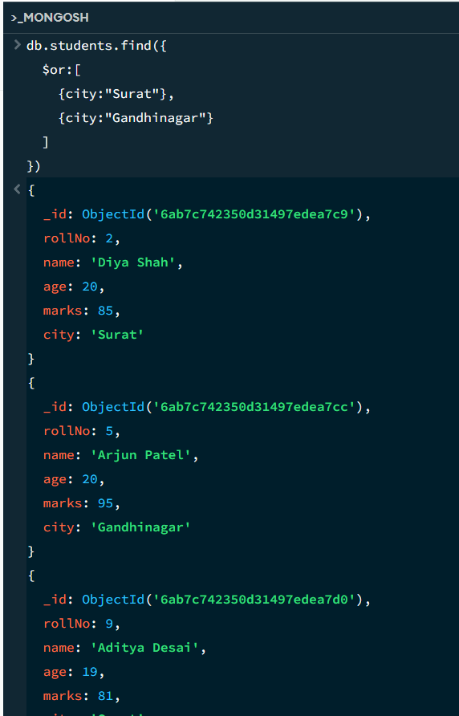

15. SORT OPERATION
A.MongoDB Query:
db. students. find (). sort({marks : 1})
Explanation: Sorts students by marks from lowest to highest. Use 1 for ascending order.
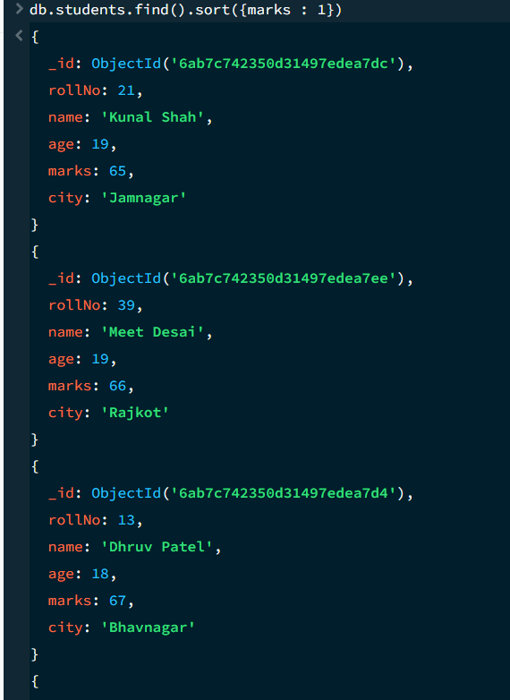

B. MongoDB Query:
db. students. find (). Sort ({marks: -1})
Explanation: Sorts students by marks from highest to lowest. Use -1 for descending order.
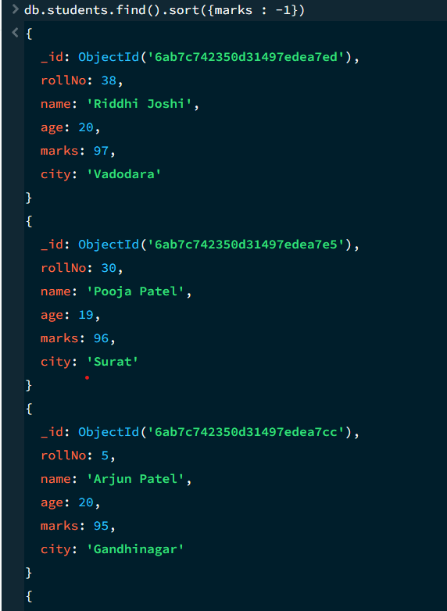
16. LIMIT OPERATION
MongoDB Query:
db. students. find (). limit (5)
Explanation: Displays only the first five documents.
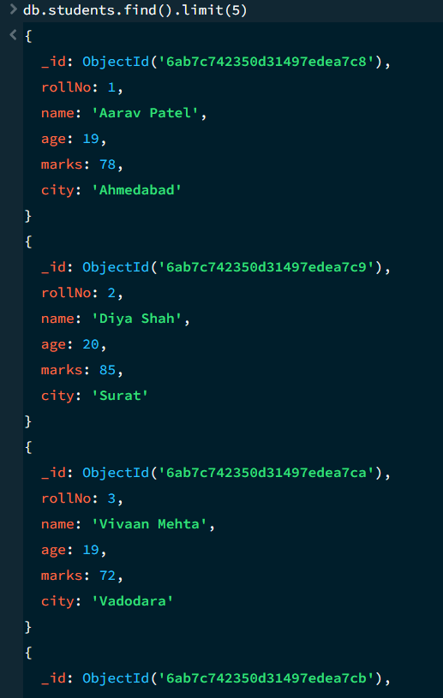

17. SEARCH BY CITY
MongoDB Query:
db.students.find({city:"Lucknow"})
Explanation: Finds all students whose city is Lucknow.
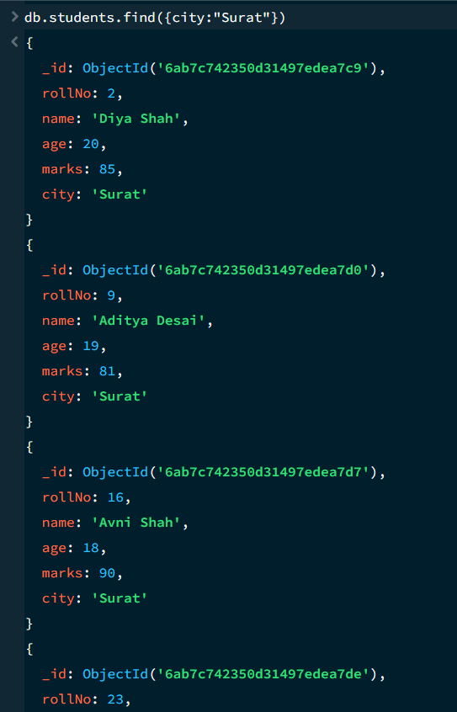

18. COUNT DOCUMENTS
MongoDB Query:
db. students. count Documents ()
Explanation: Counts documents currently present in the collection (performing after the delete function).


